CN Lab Project Report
On
CARRIER SENSE MULTIPLE ACCESS

BACHELORS OF TECHNOLOGY
In
COMPUTER SCIENCE AND ENGINEERING
(2025-2026)

Submitted by

Batch no: D13

RADHIKA 23311A05M6
SHAIK SANIA 23311A05N3
MIZBA NAUSHEEN 23311A05N9

Under the guidance of

DR.ARUNA VARANASI
Professor CSE Dept. & Dean Computers & Training

Department of Computer Science & Engineering

SREENIDHI INSTITUTE OF SCIENCE AND TECHNOLOGY

(An Autonomous Institution approved by UGC,Accredited(NBA) of AICTE,New Delhi)
Yamnampet,Ghatkesar,Hyderabad,Telangana-India 50130
2023-2027

CERTIFICATE

This is to certify that this CN Project report on “CSMA/CD” submitted by RADHIKA(23311A05M6),SHAIKSANIA(23311A05N3),MIZBANAUSHEEN(23311A05N9), in the year 2025 in partial fulfillment of the academic requirements of Jawaharlal Nehru Technological University for the award of the degree of Bachelor of Technology in Computer Science and Engineering, is a bonafide word that has been carried out by them as part of their CN Project during Third Year First Semester under our guidance. This report has not been submitted by any other institute or university for the award of any degree.

Faculty Coordinator Head of Department
Dr. Aruna Varanasi Dr. K. Shirisha
Professor, Dean Computers &Training, Professor & HOD
Department of CSE Department of CSE

ABSTRACT

The Carrier Sense Multiple Access with Collision Detection (CSMA/CD) protocol is a fundamental medium-access control technique used in traditional Ethernet networks. In this simulation, 1-persistent transmission is implemented along with the Binary Exponential Backoff (BEB) algorithm to realistically model collision handling and retransmission behavior. Multiple stations contend for a shared communication medium, detect collisions when identical backoff slots are selected, and resolve them using exponentially increasing waiting intervals. The system provides step-by-step visibility into each frame’s transmission attempts, collision occurrences, backoff values, and final outcomes, thereby enhancing understanding of how CSMA/CD manages network congestion, reduces repeated collisions, and ensures fair medium access. Although modern switched networks no longer rely on CSMA/CD, the concepts explored remain essential for comprehending MAC-layer mechanisms and contention-based protocols. The simulation further highlights the trade-off between efficiency and fairness in shared channel environments, demonstrating how exponential backoff prevents persistent collisions while balancing throughput across competing stations. By visualizing transmission timelines, learners gain deeper insight into contention resolution strategies, and ultimately the project bridges theoretical protocol design with practical network behavior, reinforcing core principles of distributed communication.

INDEX

S.No | Contents | Page No.,
1. | Objective | 5
2. | Introduction | 6-7
3. | Architecture Diagram | 8
4. | Algorithm and Code Explanation | 9
5. | Code | 10-11
6. | Sample Input | 11-12
7. | Output | 13-14
8. | Conclusion | 15

CSMA/CD

Objective

The primary objective of this project is to develop a detailed simulation of the Carrier Sense Multiple Access with Collision Detection (CSMA/CD) protocol using the *1-persistent transmission approach* and incorporating the *Binary Exponential Backoff (BEB)* algorithm. The goal is to illustrate how Ethernet networks manage medium access, detect collisions, and efficiently recover from them through adaptive retransmission strategies.

Key Objectives

- To understand the working principle of CSMA/CD in shared Ethernet environments.
- To simulate real-time collision detection using binary-based contention slots, as implemented in actual Ethernet hardware.
- To implement a practical model of Binary Exponential Backoff, reflecting realistic network behavior under high traffic.
- To log and display the status of each frame transmission, including how the *previous frame’s outcome affects subsequent frames.
- To provide a clear educational tool that demonstrates how collisions affect throughput and how backoff algorithms reduce repeated collisions.
- To strengthen understanding of MAC (Medium Access Control) layer mechanisms in computer networks.

The project ultimately focuses on providing a practical, code-driven demonstration of CSMA/CD that mimics real Ethernet behavior, making the theoretical concepts more understandable.

Introduction
Local Area Networks (LANs) frequently require multiple devices to share a single communication medium. When several devices attempt to transmit data simultaneously over a shared channel, collisions are inevitable. To handle this, networking protocols define rules governing how these devices access the medium. One such widely used protocol in traditional Ethernet networks is CSMA/CD — Carrier Sense Multiple Access with Collision Detection.
Before transmitting data, a device listens to (“senses”) the channel to determine whether it is free or busy. This prevents unnecessary collisions when the medium is clearly occupies.
All nodes connected to the same Ethernet network have equal access rights to the medium. Any device may attempt to transmit whenever the medium becomes idle.
Even if the channel appears idle, two or more devices may begin transmission at almost the same time. CSMA/CD uses physical electrical signals on the cable to detect such collisions. When a collision is detected, the transmission stops immediately.
In 1-persistent CSMA/CD, when a node senses that the channel is idle, it transmits with a probability of 1.
This strategy reduces delays but increases the possibility of collisions under high traffic.
Once a collision occurs, devices do not attempt to retransmit immediately. Instead, they wait for a random number of time slots.
The number of permitted time slots increases exponentially with the number of collisions:

- 1st collision → window = 2¹ – 1 = 1
- 2nd collision → window = 2² – 1 = 3
- 3rd collision → window = 2³ – 1 = 7
- ... up to 10 attempts (Ethernet standards)
This exponential behavior prevents the channel from becoming overloaded with repeated collisions.
CSMA/CD forms the foundation of classic wired Ethernet technologies (10BASE-T, 10BASE-2, 10BASE-5). Although modern networks use switches and full-duplex communication (eliminating collisions), CSMA/CD remains essential for understanding MAC-layer protocols, contention handling, and network performance.This simulation project brings theoretical CSMA/CD concepts to life using a detailed C program

Architecture Diagram

The CSMA/CD network consists of:
- Multiple stations (computers, nodes, devices)
- A shared physical medium (coaxial cable or twisted-pair hub)
- A common collision domain
- A MAC algorithm governing how stations send frames
- All stations in the network:
- Sense the medium continuously
- Attempt transmission when the medium is idle
- Detect collisions by monitoring voltage levels
- Use Binary Exponential Backoff to retry
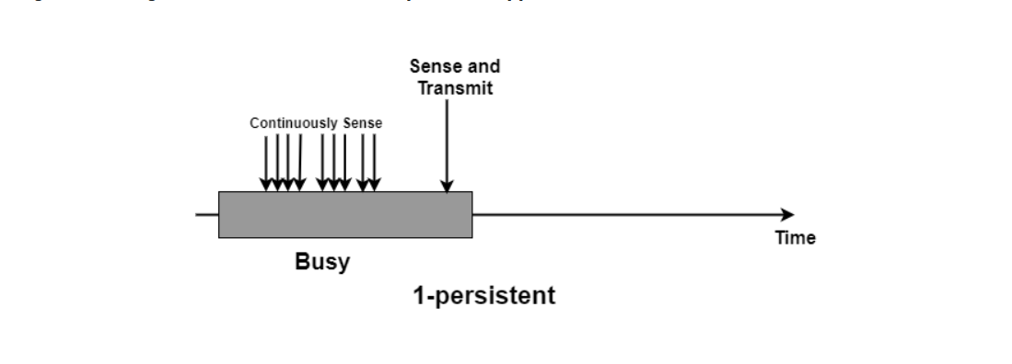
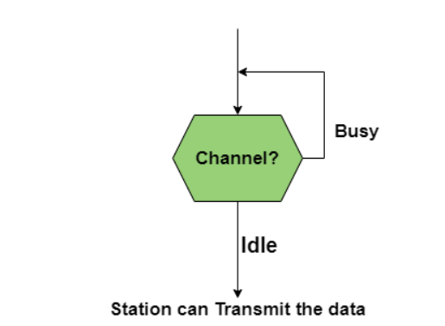
Algorithm and Code Explanation

1. Start the simulation and initialize frame counter.

2. For each frame to be transmitted:

3. For the current frame:

+ Set attempts = 0.

4. Sense the medium:

5. Binary Collision Detection Mechanism:

Both the sender and a competing station choose a backoff slot within the current BEB window.

If both choose the same slot → collision occurs.

6. If collision happens:

Increment attempt counter

Calculate the new backoff window (2^attempts – 1)

Choose a new random backoff slot

7. If attempts exceed MAX_ATTEMPTS (typically 10), transmission fails.

8. If slots differ → transmission succeeds.

9. Store the result (Success / Failed / Collided) for the next frame.

Explanation of Each Part of the Code

1. Binary Slot Selection

Instead of random collision, the simulation checks whether *two nodes select the same slot, which is how real collisions occur on Ethernet.

2. Printing Binary Representation

The code prints windows such as

1 → 1

3 → 11

7 → 111

This helps students visualize binary exponential growth.

3. Logging Prior Frame Status

Before every new frame starts, the program shows whether the previous frame was:

successful

collided

waiting

This allows us to see how backoff impacts subsequent frames.

Code

#include <stdio.h>

#include <stdlib.h>

#include <time.h>

#define MAX_ATTEMPTS 10

#define TOTAL_FRAMES 5

void print_binary(int n) {

if (n == 0) { printf("0"); return; }

int bits[32], i = 0;

while (n > 0) {

bits[i++] = n % 2;

n /= 2;

}

for (int j = i - 1; j >= 0; j--)

printf("%d", bits[j]);

}

int main() {

srand(time(NULL));

int attempts;

int backoff_sender, backoff_other;

char prev_status[80] = "No previous frame";

printf("=========== CSMA/CD Simulation ===========\n");

printf("1-Persistent Method\n");

printf("===========================================\n\n");

for (int frame = 1; frame <= TOTAL_FRAMES; frame++) {

printf("\n---------------------------------------------\n");

printf("Sending Frame %d\n", frame);

printf("Previous Frame Status: %s\n", prev_status);

printf("---------------------------------------------\n");

attempts = 0;

while (attempts < MAX_ATTEMPTS) {

attempts++;

printf("\nAttempt %d for Frame %d:\n", attempts, frame);

int max_backoff = (1 << attempts) - 1;

printf("Backoff Window = 0 to %d (binary: ", max_backoff);

print_binary(max_backoff);

printf(")\n");

backoff_sender = rand() % (max_backoff + 1);

backoff_other = rand() % (max_backoff + 1);

printf("Sender Backoff Slot = %d (", backoff_sender);

print_binary(backoff_sender);

printf(")\n");

printf("Other Station Slot = %d (", backoff_other);

print_binary(backoff_other);

printf(")\n");

if (backoff_sender == backoff_other) {

printf(">>> COLLISION DETECTED using binary exponential logic!\n");

sprintf(prev_status, "Frame %d collided", frame);

} else {

printf(">>> No collision. Frame %d transmitted successfully.\n", frame);

sprintf(prev_status, "Frame %d SUCCESS", frame);

break;

}

}

if (attempts == MAX_ATTEMPTS) {

printf("\nFrame %d FAILED after too many collisions.\n", frame);

sprintf(prev_status, "Frame %d FAILED", frame);

}

}

printf("\n=========== Simulation Complete ===========\n");

return 0;

}

Sample Input

Attempt 1 for Frame 3:

Backoff Window = 0 to 1 (binary: 1)

Sender Backoff Slot = 1 (1)

Other Station Slot = 1 (1)

>>> COLLISION DETECTED using binary exponential logic!

Attempt 2 for Frame 3:

Backoff Window = 0 to 3 (binary: 11)

Sender Backoff Slot = 2 (10)

Other Station Slot = 1 (1)

>>> No collision. Frame 3 transmitted successfully.

---------------------------------------------

Sending Frame 4

Previous Frame Status: Frame 3 SUCCESS

---------------------------------------------

Attempt 1 for Frame 4:

Backoff Window = 0 to 1 (binary: 1)

Sender Backoff Slot = 1 (1)

Other Station Slot = 1 (1)

>>> COLLISION DETECTED using binary exponential logic!

Attempt 2 for Frame 4:

Backoff Window = 0 to 3 (binary: 11)

Sender Backoff Slot = 1 (1)

Other Station Slot = 3 (11)

>>> No collision. Frame 4 transmitted successfully.

---------------------------------------------

Sending Frame 5

Previous Frame Status: Frame 4 SUCCESS

---------------------------------------------

Attempt 1 for Frame 5:

Backoff Window = 0 to 1 (binary: 1)

Sender Backoff Slot = 1 (1)

Other Station Slot = 0 (0)

>>> No collision. Frame 5 transmitted successfully.

Output

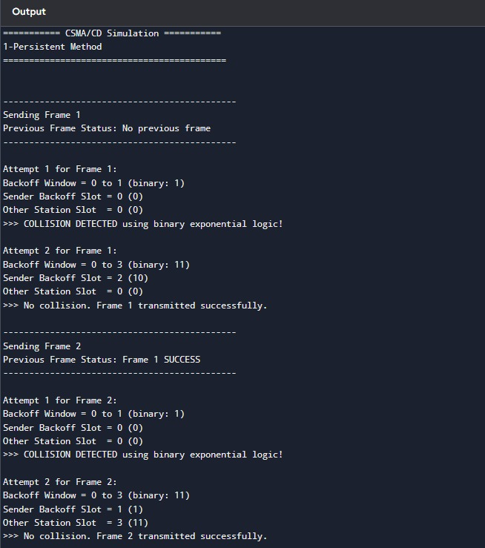

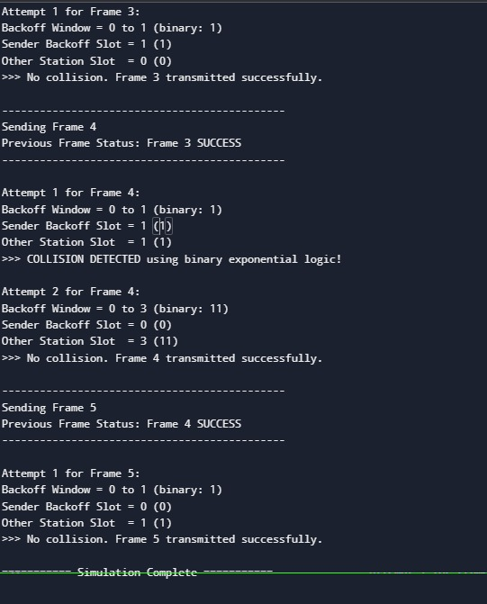

Conclusion

This project successfully demonstrates the internal working of the CSMA/CD protocol using a hands-on simulation. The implementation provides a complete model of contention handling in traditional Ethernet networks. Through the use of *Binary Exponential Backoff*, the system adaptively modifies waiting times to reduce repeated collisions and stabilize network traffic.
The simulation clearly shows how:
Collisions occur when multiple devices select the same backoff slot
Exponential backoff reduces the likelihood of repeated collisions
Channel access becomes more efficient as attempts progress
Previous frame outcomes can influence the behavior of subsequent transmissions

Overall, this project enhances understanding of the fundamental MAC-layer mechanisms that are crucial in Computer Networks. Although modern switched Ethernet no longer uses CSMA/CD, the principles remain essential for learning about network access control, fairness, and congestion management.

